**CHAPTER 3**

**PROCESS DESCRIPTION**

**3.1About the Process**

The paper "An Attention-Based Deep Learning Approach for Sleep Stage Classification with Single-Channel EEG" presents a novel method, named AttnSleep, for classifying sleep stages using single-channel EEG signals. Sleep stage classification is essential for evaluating sleep quality and diagnosing sleep disorders. Traditional methods of sleep stage classification involve manual inspection by sleep specialists, which is time-consuming and labor-intensive. Therefore, there is a strong need for automatic classification systems.

AttnSleep introduces a unique architecture composed of three main modules: multi-resolution convolutional neural network (MRCNN) for feature extraction, adaptive feature recalibration (AFR) to enhance the quality of the extracted features, and temporal context encoder (TCE) that employs a multi-head attention mechanism to capture temporal dependencies among features. The proposed system starts with the MRCNN, which extracts features from various frequency bands of the EEG signals, addressing both low and high-frequency components. The AFR module further refines these features by modeling the interdependencies between them, enhancing the representation of significant features.

The temporal context encoder (TCE) in AttnSleep uses multi-head attention with causal convolutions to efficiently capture the temporal dependencies within the EEG data. This approach is particularly effective in modeling the sequential nature of sleep stages. Unlike recurrent neural networks (RNNs), which are typically used for sequential data but come with high computational complexity, the TCE in AttnSleep offers a more efficient and parallelizable solution.

AttnSleep was evaluated using three public datasets, demonstrating superior performance compared to state-of-the-art methods in various evaluation metrics. One of the notable contributions of this work is the design of a class-aware loss function that addresses the issue of data imbalance without adding computational overhead. The class-aware loss function helps to mitigate this issue, ensuring more accurate and balanced classification results.

The results indicate that AttnSleep significantly outperforms existing techniques, making it a robust solution for automatic sleep stage classification. The authors have also made their source code, experimental data, and supplementary materials publicly available, fostering transparency and enabling further research in this field.

Overall, the proposed AttnSleep model leverages advanced deep learning techniques to provide an efficient and effective solution for sleep stage classification using single-channel EEG data. Its innovative architecture addresses key challenges in feature extraction and temporal modeling, setting a new benchmark for automatic sleep stage classification systems.

**3.2 Technologies/Tools used**

**1. Single-Channel EEG Signal:**

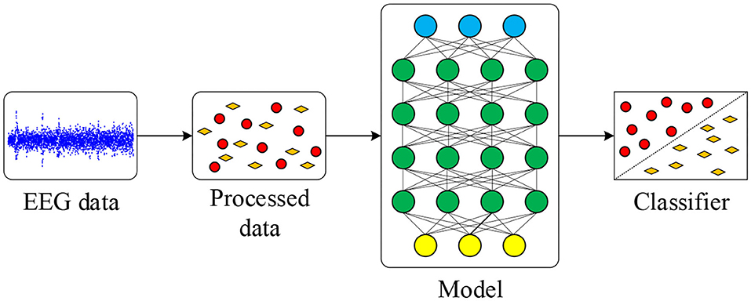The primary data source for the study was single-channel electroencephalogram (EEG) signals. These signals provide electrical activity of the brain and are essential for sleep stage classification. The study mentioned in Figure 3.1 focused on utilizing single-channel EEG due to its simplicity and ease of use compared to multi-channel setups.

**Figure 3.1: Single-Channel EEG Signal**

**2. Multi-Resolution Convolutional Neural Network (MRCNN):**

The MRCNN is a novel feature extraction module that captures both low and high-frequency features from EEG signals. It employs two branches of convolutional layers with different kernel sizes, each tailored to extract features from specific frequency bands. This multi-resolution approach ensures that the model can capture a wide range of important features from the EEG data.

**3. Adaptive Feature Recalibration (AFR):**

The AFR module is designed to enhance the quality of features extracted by the MRCNN. It models the inter-dependencies between features and adaptively recalibrates them to highlight